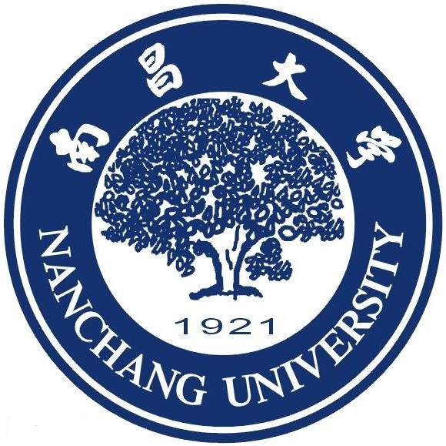
南 昌 大 学
NANCHANG UNIVERSITY
NANCHANG UNIVERSITY CERTIFICATE OF DEGREE
MASTER’S DEGREE CERTIFICATE
This is to certify that 姓名, 性别, born on 出生年月日, was admitted to study in master’s degree program of Nanchang University majoring in 专业名称, thus was granted graduation after she/he had duly complete all the required courses in the academic program and passed the graduate dissertation. In conformity with the articles of ‘Regulation Regarding Academic Degrees of the People’s Republic of China’, she/he has been conferred to the degree of Master of 学位类别.
Chairman of the Academic Degree Evaluation Committee

Date: Month/Day/Year
(此处与证书一致）

Certificate Serial Number: 证书编号
中国.江西.南昌市 Add: NanChang JiangXi Province P.R.China
电话(Tel)：0791-88305981 传真(Fax)：0791-88305981 邮编：330031
Seal of
Nanchang University

